Retno Indah Nurita
Curriculum Vitae

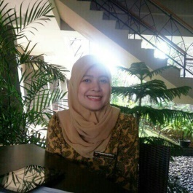

PERSONAL DETAILS
Birth : November 5th, 1992
Phone : 087739500953
Mail : ninonurita@gmail.com
Skype : nino.nurita
Address : Cungkuk Raya Street, no. 161 Rt 06 Rw 09 Ngestiharjo Kasihan, Yogyakarta City, Indonesia. 55182

EDUCATION
Bachelor’s Degree of Politics | Muhammadiyah University of Yogyakarta | International Relations | Oct 2014

RESEARCH EXPERIENCE
Japan’s Response Towards China’s Military., June 2014

WORK EXPERIENCE
PT. Netindo Solution Group | Business Sales Support | Jan 2015
7 years experience as a Translator English-Indonesia and vice versa
Indonesian Translator for Ivaluhealth.net
Subtitling for movie series (Scandal Movie, Castle Movie)
Transcript 100 hours audio Indonesia
Admin Support

SKILLS
- Write an article, a paper, a journal with many kind of theme
- Translator, Transcriber and proofreader Bahasa – English, English – Bahasa, English - Javanese
- Subtitling Movie from English – Bahasa, English - Javanese
- Data entry to Microsoft Word or Excel
- Copywriting
- Customer Service Support

